**COMSATS UNIVERSITY ISLAMABAD**

**ATTOCK CAMPUS**



**ASSIGNMENT NUMBER 1**

**Name:** Vareesha Shuaib

**Reg no:** SP22-BSE-018

**Subject:** Human Computer Interaction

**Berkshire Hathaway**

# Background

**Berkshire Hathaway Inc.** ([/ˈbɜːrkʃər/](https://en.wikipedia.org/wiki/Help:IPA/English)) is an American [multinational](https://en.wikipedia.org/wiki/Multinational_corporation) [conglomerate](https://en.wikipedia.org/wiki/Conglomerate_(company)) [holding company](https://en.wikipedia.org/wiki/Holding_company) headquartered in [Omaha, Nebraska](https://en.wikipedia.org/wiki/Omaha,_Nebraska). Originally a textile manufacturer, the company transitioned into a [conglomerate](https://en.wikipedia.org/wiki/Conglomerate_(company)) starting in 1965 under the management of chairman and CEO [Warren Buffett](https://en.wikipedia.org/wiki/Warren_Buffett) and vice chairman [Charlie Munger](https://en.wikipedia.org/wiki/Charlie_Munger) (from 1978 to 2023). [Greg Abel](https://en.wikipedia.org/wiki/Greg_Abel) now oversees most of the company's investments and has been named as the successor to Buffett. Buffett personally owns 38.4% of the Class A voting shares of Berkshire Hathaway, representing a 15.1% overall economic interest in the company.[[4]](https://en.wikipedia.org/wiki/Berkshire_Hathaway#cite_note-14A-4)

# Screenshot

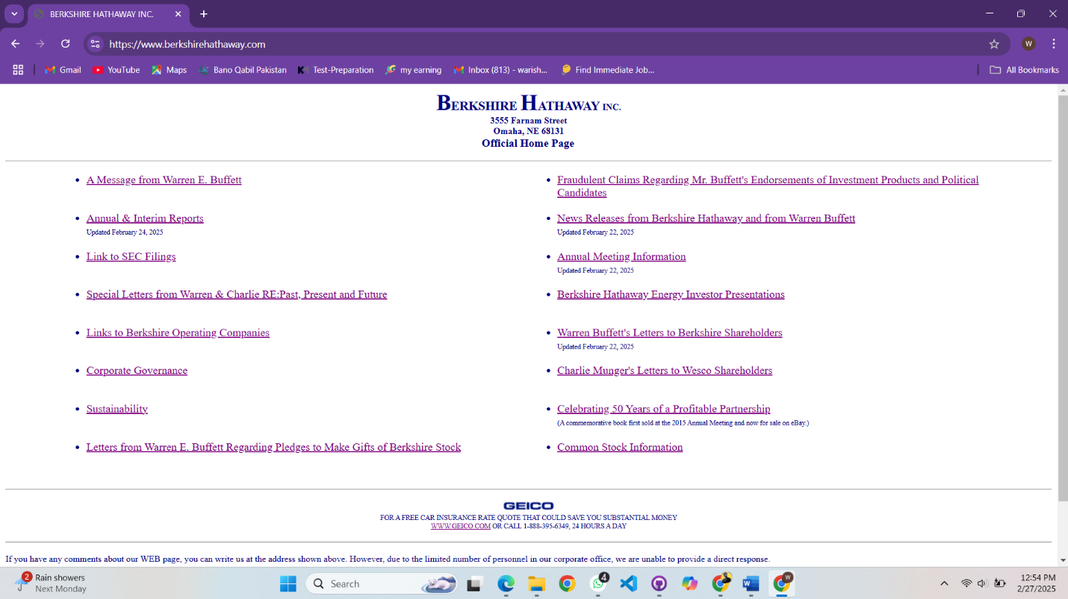

# Shortcomings:

* **Minimalist to a Fault** – While minimalism is good, this site lacks engaging visuals and structure.
* No Responsive Design – The website doesn't scale well for mobile users.
* **Lack of Navigation** – There’s no clear menu; users have to scroll and manually look for links.
* **Plain Text & Styling** – The fonts, colors, and overall layout are very basic, making the site feel uninviting.
* **No Visual Hierarchy** – Key information isn’t emphasized, making it hard to scan.
* **No Call-to-Actions (CTAs)** – There are no buttons or prompts guiding users.
* **No Modern Features** – The website lacks images, animations, or interactive elements.

# Possible Enhancements:

* **Use a modern layout** – A structured and visually appealing homepage.
* **Make it mobile-friendly** – Ensure responsive design for all devices.
* **Improve navigation** – Add a header menu for quick access.
* **Use proper typography & colors** – A modern font and readable contrast.
* **Add visual elements** – Images, icons, and background styling.
* **Introduce CTAs** – Buttons for user engagement.
* **Enhance usability** – Clear sections and content organization.

# Redesign into Good design:

* **Redesign using HTML/CSS:** <Berkshire-Hathaway.html>

# Good Design Screenshot:

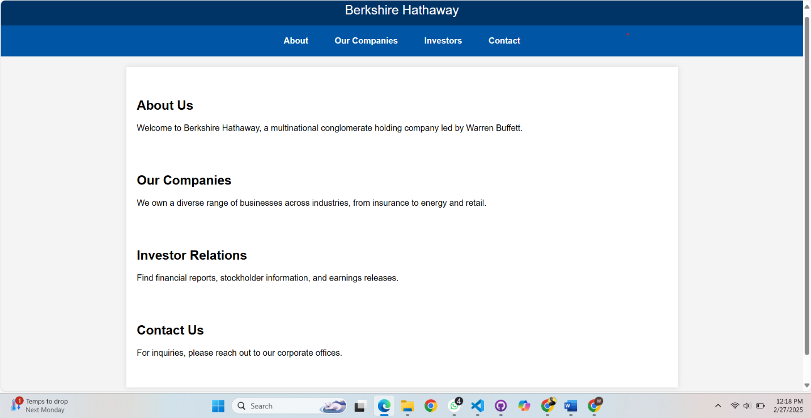

# Enhancements:

* **Modern & Clean Layout** – Uses structured sections for clarity.
* **Responsive Design** – Works on both desktop and mobile.
* **Clear Navigation** – A well-organized navigation bar.
* **Engaging Typography & Colors** – Professional fonts and a consistent blue theme.
* **Improved Readability** – White background with well-spaced text.
* **User Guidance** – Sections are clearly defined with headings.